Jean Cottraux’s COGNITIVE MODEL
Source: Cognitive Therapies, Polirom 2003
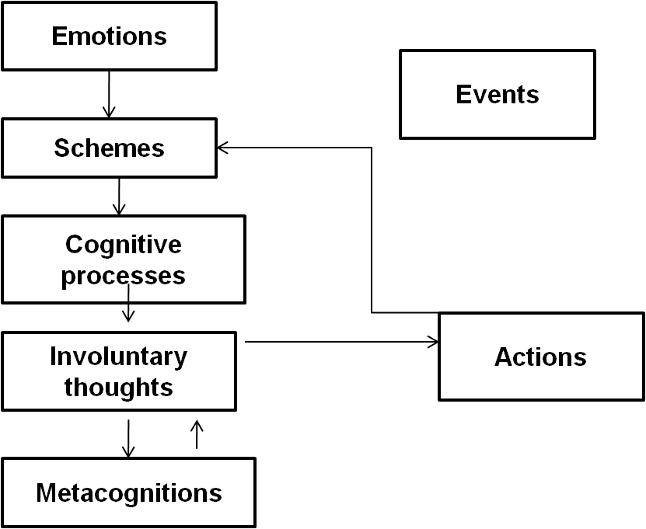
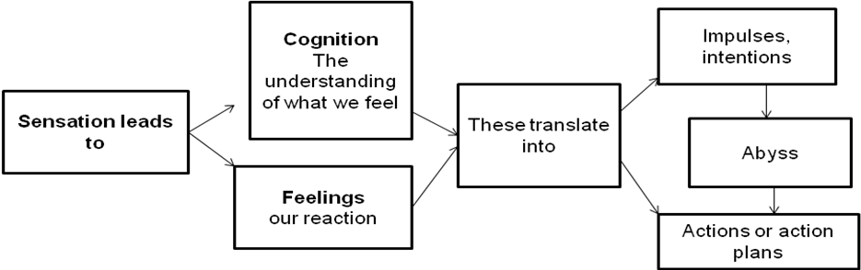
Neurologists argue that each time we feel a sensation, the information circulates in the following order:
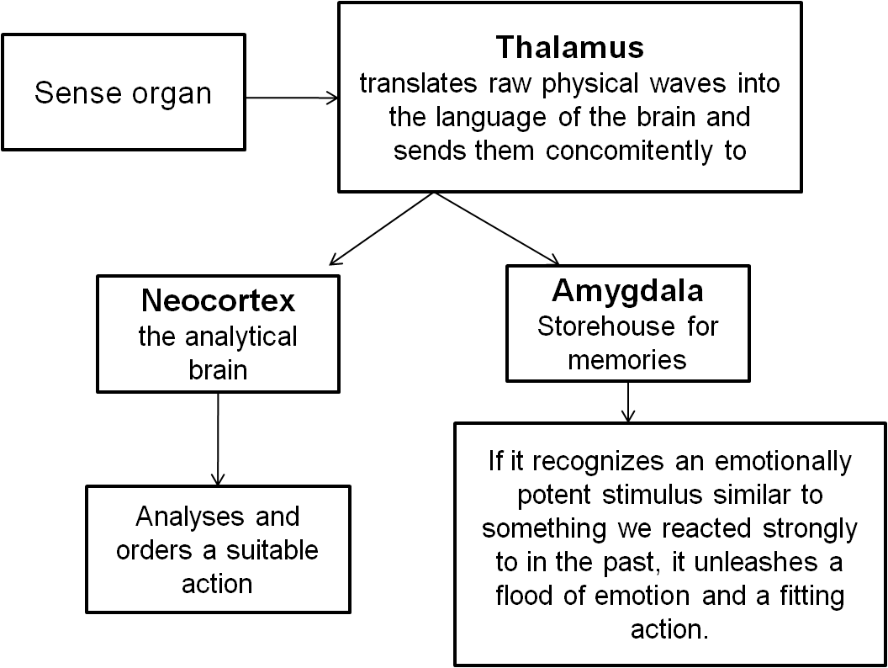
Every individual will react to an event through emotions, which will activate certain schemas.
Schemas
- Are organized structures, which contain knowledge about, as well as the expectations of the individual from the exterior world.
Beliefs
- Are a set of personal views regarding oneself, the others and the world, which constitute a system of interpretation, or the personal life philosophy.
- May be structured in systems of rational beliefs – adapted to the personal culture of the subject –, or
- in systems of irrational beliefs.
Levels of cognition
1. The unconscious level: schemas
- Are organised structures, which contain knowledge about, as well as the expectations of the individual from the exterior world.
- Function in an automated manner.
- Are located in the semantic memory and, apparently, correspond to two networks stabilized by neurons.
- Belong to the daily routine and are activated by regular events.
2. The preconscious level: cognitive events
- Contains involuntary thoughts, interior monologues and involuntary preconscious mental images, which make possible the access to unconscious schemas.
- Corresponds to the activation of schemas through emotionally induced situations.
3. The conscious level: focused attention
- Attention focuses on a certain number of elements from the surrounding reality.
- It results from schemas, which polarize the perception based on their content.
4. The metacognitive level: the second degree cognition
- Cognitions about cognitions, interpretation of interior monologues.
- May be positive or negative.

Connections between the conscious and the unconscious are realized through:
1. Involuntary cognitive processes:
- Unconscious, fast, they take place effortlessly, require little or no attention, and are difficult to adjust.
- Correspond to the schemas.
- Lead to involuntary thoughts, which appear at a level near to the consciousness.
2. Controlled cognitive processes:
- Conscious, slow, involve effort and attention, and are easy to adjust.
- Correspond to the logical thinking.
- Lead to a decentralization in relation to oneself.
The process of assimilation:
- The schema will try to interpret the event, trying to compare it with existing assumptions and beliefs.
The process of accommodation:
- The schemas adjust if the event is not compatible with them.

Information may be processed in two ways:
1. bottom up:
- comes from environmental stimuli and is directed towards the upper cognitive processes;
- is under the control of data received from the external environment.
2. from above:
- is under the influence of concepts or theories;
- prevails over external information in the learning process, in the recollection of similar situations and already defined schemas of thinking;
- lack of flexibility and permeability of schemas is responsible for psychological drawbacks and the recurrence of undesired behaviours.

ANNEX 3: Maladaptive Schemas
Source: Tara Bennett-Goleman,
Emotional Alchemy: How the Mind Can Heal the Heart
Crown Publishing Group, 2002 (Romanian translation, Curtea Veche, Bucharest, 2002)

A schema can be adaptive or maladaptive.
A maladaptive schema is a mental habit, a strong combination of negative thoughts and feelings. It tries to avoid conflicting mental states.
Maladaptive schemas represented at some point a suitable solution for a problem, which we faced during childhood. They are flawed solutions to satisfy one of the four essential needs: security, relationships with others, autonomy, competence. When these needs remain unsatisfied, they lead to the development of schemas.
Each schema has its own emotional fingerprint and it revives the feelings experienced during the original traumatic events.
The strategies of a schema are incomplete solutions to the inevitable problems we face in life. They might lightly reduce the sufferance during critical moments, but do not really solve the problem.
Schemas handle the imperative needs, but cause us to think and act in ways that actually prevent us from satisfying those needs.
Schema-based responses are exaggerated reactions to difficult situations.
Schemas are storage systems, which contain the emotional elements that have been well assimilated. These continue to assimilate what we experience according to a specific pattern.
Some schemas represent the way in which we sacrificed our own potential in order to maintain the relationships with the others.
Schemas function like mental lenses that portray the surrounding world very differently than the way it actually is through the distortion of attention, memory and perception.
Maladaptive schemas are life patterns owned to distorted opinions that people have about themselves and others.
Some schemas function like scenarios that seem fated to repeat several times in someone’s life.

How a schema can be recognized
Each schema has its own “signature”, a pattern of stimuli and typical reactions, which makes it possible to recognize it after:
- situations, which trigger it,
- feelings and thoughts, which appear automatically, and after
- typical reactions, which accompany those states (and which are counterproductive).

How we can free ourselves from the domination of schemas
We begin to heal ourselves when we are ready to relive the feelings that hold tight together these patterns. It takes courage to face the feelings hidden by affective patterns.
What can we do?
- Become aware of what is happening by looking at ourselves in an honest manner, no matter how difficult that might be.
- Relieve the pain or the fright that hides behind these schemas, if nothing else just to realize that we can overcome this step.
- Observe the thoughts, which accompany these feelings, and see to which extent they justify what we do. Thoughts feed into the affective reaction. Extremely powerful reactions suggest that we find symbolical meanings in something that occurred, and those feelings release the reaction. Remembering similar situations from the past, especially from childhood, helps identify the pattern of the schema, which troubles us.
- We should pay attention to our actions and impulses at all levels of manifestation: what we say (loud or in our mind, verbally or non-verbally), how we say it, what we do, what we felt like doing but restrained ourselves… We shouldn’t suppress our emotions, but we should also not react under their impulse. We can live them without doing what they want us to do.
- We shouldn’t let ourselves be dominated by emotional reactions and we should observe the way in which they change through our emotional awareness and through the choice of reactions, which are more suitable to the present situation.
The tools of awareness are attention and acceptance.
Attention (or contemplation) should be practised permanently in order to become a useful tool during crisis situations. It consists of simply observing the feeling, without becoming absorbed by it and without fully identifying with it and with the thoughts that accompany it automatically.
We concentrate on the awareness process, and not on its content.
Awareness is not repression; instead it presumes experiencing the feeling and observing the thoughts, sensations and impulses we are having.
As a result, reactions will be specific, not typical.

The main maladaptive schemas described by specialists are:
- Fear of abandonment
- based on the permanent fear that people will leave us;
- may have the origin in a real experience from childhood;
- typical emotions of this schema are: deep sadness, feeling of isolation, fear and panic of being alone;
- it exteriorizes through a tight attachment to the people around, which may lead to anxious attachment.
- Possible behaviour:
- testing the stability of the relation through repeated questions;
- excessive anxiety each time there is tension in the relationship;
- acceptance of negative relationships and compromises out of fear of being abandoned;
- quitting the relationship before the other person;
- extreme sensibility in front of any sign of distancing from the ones around us;
- constant and irrational jealousy;
- anxiety when the person we are attached to is away, no matter what the reason might be.
- Solutions:
- carry an analysis of the thoughts, which feed into the fear of abandonment;
- become aware of and contemplate the feelings released by an abandonment;
- confront the fear of abandonment;
- test the inner resources for living alone;
- choose a stable life partner.

- Deprivation
- relies on the deep conviction that personal needs cannot be satisfied;
- appears during childhood, due to nurture, warmth or affection deprivation, or to lack of proper guidance;
- at adulthood, the schema makes people become oversensitive to any sign of being ignored or not being helped, especially in close relationships;
- the active feelings are: sadness or despair of a person, who will never be understood or taken into consideration, fury, loneliness, fear that the wishes will not be fulfilled if they are spoken out loud.
- Possible behaviour:
- extreme kindness towards other people, refusal to communicate one’s own needs under the expectation that they should be guessed by the others;
- sometimes, persons affected by this schema have unlimited claims regarding the way other people should understand and help them.
- Strategies of the schema:
- exaggerated care for the needs of others, blaming oneself for caring too much about the needs of others in order to obtain the necessary attention, constant disguise of good-humour and display of inexhaustible energy. People affected by this schema regularly chose careers in social assistance, medical assistance and physiotherapy, where they work until exhaustion;
- strategies of avoidance, protection by maintaining distance in the relationship, concealing true feelings and needs.
- Solutions:
- become aware of the tendency to distort the attitude of others towards us;
- learn to express own needs and desires in a clear and proper manner;
- avoid relationships with aggressive and indifferent persons;
- accept childhood traumas, which generated the schema, express your grief over them and learn to overcome them.

3. Subjugation
- persons who develop this schema give up easily on their own needs and desires, and learn to behave helplessly and powerlessly in relation to those who assume leading roles;
- originates in childhood, where authoritarian parents imposed their will through violence, threats and disapproval.
- Feelings:
- fury;
- resentment;
- anger.
- Possible behaviour:
- excessive concern to please others;
- submission to the requests of the dominant partner;
- quick renouncement to any personal need, or resistance accompanied by violent reactions to the slightest attempt of domination or authority;
- inability to impose onto others expectations of their limits, ready to work for others and even in their place;
- unable to express resentments, but ready to take revenge on people by delaying, postponing and ignoring deadlines.
- Strategies:
- avoidance;
- revolt;
- refusal of attachment, avoidance of situations where one could be trapped and dominated;
- subjugation may go all the way to the inability to recognize one’s own preferences, opinions and even one’s own identity;
- the person prefers to keep secret his own preferences and desires for the sake of the relationship.
- Solutions:
- become aware of the schema;
- acknowledge automated reactions of anger and thoughts unleashed by the fear of being dominated;
- learn to communicate one’s own needs and desires.

4. Mistrust
- characterized by extreme suspicion, a deep conviction that people cannot be trusted;
- originates in an affective, physical or sexual abuse that took place during childhood.
- Feelings:
- fury,
- fear,
- shame.
- Possible behaviour:
- excessive caution in relationships;
- closure and reservation towards the others;
- sometimes there is a tendency to engage in relationships with partners, who behave offensively, in order to fulfil the “prophecies” of the schema;
- tendency to idealize a person at the beginning of a relationship, only to consider him a traitor when the relationship is ended;
- tendency to revive the traumatic situation from childhood through connection with abusive persons;
- the victim may become an aggressor himself, making possible the perpetuation of the abuse;
- avoidance of close friendships based on a conviction that people have a hidden agenda when befriending one another.
- Solutions:
- engage in therapy with abuse counselling;
- learn to communicate the powerful feelings experienced during the traumatic event: fury, feeling of being betrayed, shame, fear;
- become aware of the tendency to be suspicious, reject self-destructive thoughts and try to offset them through positive thoughts;
- completely reject any kind of abuse in a relationship;
- resist the attraction of abusive partners.

5. Unlovability
- characterized by the involuntary assumption that we are not worthy of being loved, that we don’t have enough qualities, that if someone were able to see us deep inside, would realize how many failures we have and would no longer love us;
- the origin of the scheme lies in messages given by excessively critical parents, who insult and humiliate their children;
- Feelings:
- shame,
- humility,
- vulnerability,
- anxiety.
- Possible behaviour
- indifference, surrender, acceptance of a negative image of oneself, ability to regard oneself with the despise parents used to show one as a child. People are hard to get to know closer, they hide and don’t disclose their feelings and emotions;
- or, the opposite: bolstering, arrogance, overly-confident attitude.
- Solutions:
- recognize and acknowledge the schema indicators;
- get rid of obsessive thoughts regarding one’s failures;
- dismiss doubts regarding oneself;
- acquire a realistic recognition of one’s personal qualities;
- understand emotional reactions and learn to trust those who love us the way we are.

6. Social exclusion
- inner conviction that we “don’t belong to...”, that we are not being accepted by a certain community, which, in turn, creates of feeling of non-involvement;
- schema functions on the self-fulfilling prophecy basis: fear of being rejected causes an inappropriate behaviour, which eventually leads to rejection.
- Feelings:
- anxiety;
- deep sadness;
- loneliness.
- Possible behaviour:
- isolation, tendency to avoid groups, loneliness;
- increasing efforts of integration through excessive attention and total adoption of qualities required by the group;
- nonconformist behaviour: excessive display of the “outlaw” role, seen as an accomplishment.
- Solutions:
- become aware of and contemplate the thoughts that accompany the feeling of exclusion;
- learn to control anxiety and to relax emotionally in a group;
- develop communication abilities.

7. Vulnerability
- exaggerated fear that something terrible is about to happen;
- normal fears get out of control, a minor reason for anxiety may get over-amplified into a potential disaster;
- the root of vulnerability lies either in the behaviour of a parent we are imitating, or in dangerous situations we might have experienced during childhood.
- Feelings:
- worry;
- anxiety;
- exaggerated fear;
- panic.
- Possible behaviour:
- excessive efforts for success despite a permanent fear of failure. These lead to the “impostor” phenomenon, in which the person, who did well, feels deep inside that he committed a fraud and lives terrorized by the thought that the truth will one day be unveiled;
- failure-driven behaviour;
- fear of failure blocks the acquisition of new knowledge and skills, causes unjustified delays, which, in turn, lead to failure.
- Solutions:
- awareness of the internal mechanisms of discouragement;
- proper evaluation of real skills and abilities;
- true evaluation of accomplishments.

9. Perfectionism
- inner conviction that “you have to be perfect”;
- the root of this scheme lies in the need to acquire the love of others through exceptional performances;
- it leads to overrated, unrealistic expectations of oneself and the others;
- it robs away the joy of life;
- the distorted lenses of perfectionism target each flaw or minor error, which turns into a cause for criticism and self-criticism, and a reason to reprimand oneself mercilessly.
- Feelings:
- fear of not being capable or not having time to realize what one has planned;
- a constant feeling of having to do more and better;
- lack of patience and irritation on the surface;
- sadness and melancholy deep inside.
- Possible behaviour:
- dependent attachment on one’s work to the prejudice of personal life, health, social relations and capacity to enjoy life;
- excessive concern with one’s exterior image, social status, quantity and quality of goods acquired;
- tendency to impose onto others and oneself extremely high standards.
- Solutions:
- become aware of and try to take apart the patterns of flawed thinking;
- give up self-criticism and self-accusations;
- lower the standards to realistic levels;
- discover the simple joys of life.

10. Entitlement
- is an emotional pattern that concentrates on the rejection of the limits one has in life;
- those who experience this schema feel that they are very special and, as such, entitled to have everything they want;
- the root lies in:
  - spoiled behaviour encouraged during childhood;
  - excessively demanding attitude of parents, whose love was conditioned on the qualities of the child;
  - lack of affection, attention or material goods experienced during childhood.
- entitlement develops as a reaction to an injustice suffered during childhood
- Feelings:
- vanity;
- pride;
- lack of compassion;
- fake superiority to hide a feeling of inferiority;
- frustration to rejections.
- Possible behaviour:
- lack of discipline;
- tendency to satisfy the first impulses and desires, independent of the consequences;
- chaotic life-style;
- lack of interest towards cleaning and tidiness in the house;
- lack of interest regarding the negative effects this schema might have on others.
- Solutions:
- become aware of the strong feelings that prompt this schema;
- become aware of the negative effect this schema has on others;
- assume responsibility for one’s obligations and duties;
- become conscious of the impulses and learn to ignore them.

Notice
We should not be afraid to identify the schemas even if we “don’t trust the psychologists” and “don’t want to heal our wounds through psycho-therapy” (quotation from a critical analysis). An identified suffering, even in conventional terms, becomes an assumed suffering. Denial, the greatest obstacle to our spiritual healing, has been overcome. Now it is possible to begin to choose freely the way to heal oneself. Courage! (Mother Siluana)

Source: Tara Bennett- Goleman, „Emotional Alchemy: How the Mind can Heal the Heart“

